50 Port 2U Rackmount CAT3/TELCO 6-Pin Patch Panel (PPAN-50-T)
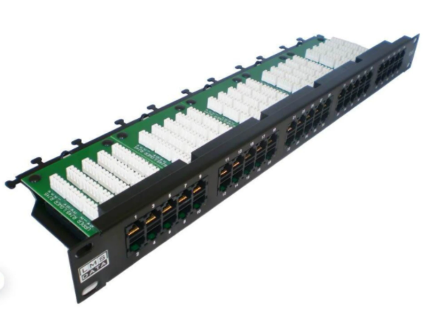

Description:
The LMS Data PPAN-50-T is 50 Port enhanced CAT3 and Telecommunications Patch Panel for working in low bandwidth applications of that of legacy PABX Telco applications.

Fully certified to CAT3/Telco standards allowing typical voice call cables to be terminated and thus patched via the 6-PIN front connection ports.

Long-life, nickel plated female ports are coupled with a vertical designed Krone(tm) IDC terminal IDC together with rear cable management bar and tabs.

Key Features:
- Certified CAT3/TELCO 50 Way Patch Panel
- Standard 6-Pin Ports with Krone(tm) IDC Punchdown
- 2u High means it fits in the smallest of data cabinets
- Part of the Synthesis 25-Year Warranty Solution

Specifications
- 48-Port, High-Density 2-U Through Coupler Patch Panel
- Performance Cat5e UTP certified - Gigabit Compliance
- Easy-Clip, modular through coupler design*
- Meets or Exceeds current Category 5e performance
- Built-in LAN port redundancy - Easy to swap out
- High conductive, gold-plated RJ45 connections
- Individual port numbering (1-48)
- Supplied with x2 clip-on alloy rear cable management bars
- Supplied with standard M6 cage nuts, bolts and washers

Applications:
- Office, Education and Home Structured Cabling Installs
- Ideal for Gigabit Ethernet (1000Mbps) Data Networks
- Create fault tolerant LANs by simply patching ports

Product Code:
- Part Number: PPAN-50-T
- EAN: 8400800013286
- Weight: 2 Kg approx.

Technical Specifications:
- Port Count：50 Ports UTP
- Dimensions：2U 19-Inch Design Format
- Design：6-Pin Telco Ports, Numbered
- Performance：ISO/IEC-11801
- Ports/IDC Connects ：Nickel and Phosphor Bronze
- Port Identification： Numbered
- Fixings： Supplied M6 Nuts and Bolts
* Specifications and product design are subject to change. E&OE.

